# Department of Computing

**CS 212: Object Oriented Programming**

**Class: BESE-11AB**

**Lab# 05: Java Arrays**

**Date: 7th April, 2021 Time: 2:00pm- 4:50pm, 09:00am-11:50 am**

**Instructor: Ms. Hania Aslam**

## Learning Objectives

The objective of this lab is to introduce the concepts of multi-dimensional arrays. In particular, the students are assumed to have basic understanding of the concepts covered in class. However, more focus is put on implementing these constructs in the Java language.

## Task #1:

Write a Java application to multiply two matrices (populated with user input) of the dimensions 3 x 3 i.e. 3 rows and 3 columns.

**Hint:** In case of matrix multiplication, one row element of first matrix is multipliedby all columns of second matrix.

### For Example:

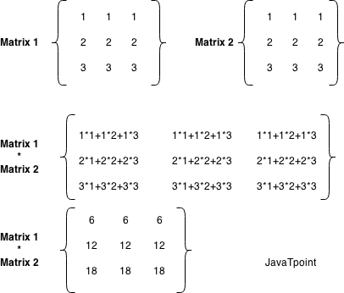

**Code:**

package com.company;  
  
import java.util.Scanner;  
  
public class Task01 {  
  
 public static void main(String[] args) {  
  
 //Initializing arrays for representation of matrices  
 int [] [] matrix_1 = new int [3] [3];  
 int [] [] matrix_2 = new int [3] [3];  
 int [] [] res_matrix = new int [3] [3];  
 int sum = 0;  
  
 Scanner sc = new Scanner(System.*in*);  
  
 //Taking the elements of Matrix 1 as input  
 System.*out*.println("Enter the elements of Matrix 1");  
  
 for (int i = 0; i < 3; i++){  
  
 for (int j = 0; j < 3; j++){  
  
 System.*out*.printf("A-%d%d: ", i+1, j+1);  
 matrix_1[i][j] = sc.nextInt();  
  
 }  
 }  
 System.*out*.println();  
  
 //Taking the elements of Matrix 2 as input  
 System.*out*.println("Enter the elements of Matrix 2");  
  
 for (int i = 0; i < 3; i++){  
  
 for (int j = 0; j < 3; j++){  
  
 System.*out*.printf("B-%d%d: ", i+1, j+1);  
 matrix_2[i][j] = sc.nextInt();  
  
 }  
 }  
 System.*out*.println();  
  
 //Printing Matrix 1 on console  
 System.*out*.println("Matrix 01");  
 System.*out*.println("---------");  
 for (int i = 0; i < 3; i++){  
  
 for (int j = 0; j < 3; j++){  
  
 System.*out*.print(matrix_1[i][j] + " ");  
 }  
 System.*out*.println();  
 }  
 System.*out*.println();  
  
 //Printing Matrix 2 on console  
 System.*out*.println("Matrix 02");  
 System.*out*.println("---------");  
 for (int i = 0; i < 3; i++){  
  
 for (int j = 0; j < 3; j++){  
  
 System.*out*.print(matrix_2[i][j] + " ");  
 }  
 System.*out*.println();  
 }  
 System.*out*.println();  
  
 System.*out*.println("Matrix 01 * Matrix 02");  
 System.*out*.println("---------------------");  
  
 //Nested for loops for matrix multiplication  
 System.*out*.println();  
 for (int i = 0; i < 3; i++){  
  
 for (int j = 0; j < 3; j++){  
  
 for (int k = 0; k < 3; k++){  
  
 sum = sum + matrix_1[i][k] * matrix_2[k][j];  
 }  
 res_matrix[i][j] = sum;  
 sum = 0;  
 }  
 }  
  
 //Displaying the resultant matrix i.e, output  
 for (int i = 0; i < 3; i++){  
  
 for (int j = 0; j < 3; j++){  
  
 System.*out*.print(res_matrix[i][j] + " ");  
 }  
 System.*out*.println();  
 }  
 }  
}

**Output Screenshot:**

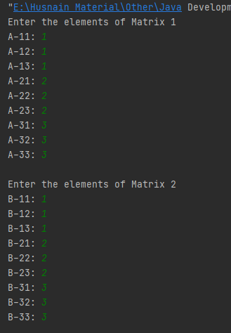

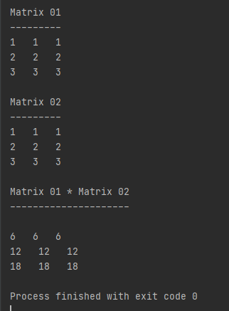

**Task # 2:**

Write a Java program to input elements into an array from the user. Your program shall then find and display all duplicate elements present in the array.

**Code:**

package com.company;  
  
import java.util.Scanner;  
  
public class Task02 {  
  
 public static void main(String[] args) {  
  
 int no_of_elements;  
  
 Scanner sc = new Scanner(System.*in*);  
  
 //Taking input how many elements the user wants to enter  
 System.*out*.print("No. of elements you want to enter in the array: ");  
 no_of_elements = sc.nextInt();  
  
 //Creating an array the size of which depends on the input from the user  
 int [] arr = new int [no_of_elements];  
  
 //For loop for taking all the elements of the array as input from the user  
 for (int i = 0; i < no_of_elements; i++){  
  
 System.*out*.printf("Enter Num-%d: ", i+1);  
 arr[i] = sc.nextInt();  
  
 }  
 System.*out*.println();  
 System.*out*.println("Duplicate Numbers");  
 System.*out*.println("-----------------");  
  
 //Double for loops for checking if a number is repeated more than once in the array  
 for (int j = 0; j < no_of_elements; j++){  
  
 for (int k = j + 1; k < no_of_elements; k++){  
  
 if (arr[j] == arr[k]){  
  
 System.*out*.println(arr[j]);  
 }  
  
 }  
 }  
  
 }  
}

**Output Screenshot:**

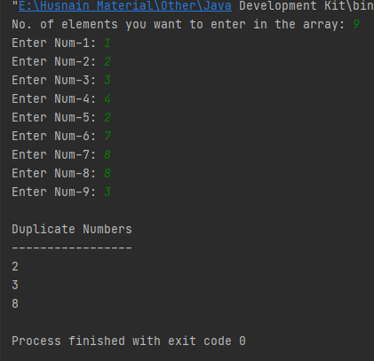

## Task #3:

Write a Java program to input elements into an array from user, then find and display the maximum and minimum element in the array.

**Code:**

package com.company;  
  
import java.util.Scanner;  
import java.util.Arrays;  
  
public class Task03 {  
  
 public static void main(String[] args) {  
  
 int no_of_elements;  
  
 Scanner sc = new Scanner(System.*in*);  
  
 //Taking input how many elements the user wants to enter  
 System.*out*.print("No. of elements you want to enter in the array: ");  
 no_of_elements = sc.nextInt();  
  
 //Creating an array the size of which depends on the input from the user  
 int [] arr = new int [no_of_elements];  
  
 //For loop for taking all the elements of the array as input from the user  
 for (int i = 0; i < no_of_elements; i++){  
  
 System.*out*.printf("Enter Num-%d: ", i+1);  
 arr[i] = sc.nextInt();  
  
 }  
 System.*out*.println();  
 Arrays.*sort*(arr); //Sorting the array  
 //Printing Desired Output  
 System.*out*.println("Maximum Number: " + arr[arr.length-1]);  
 System.*out*.println("Minimum Number: " + arr[0]);  
 sc.close();  
 }  
}

**Output Screenshot:**

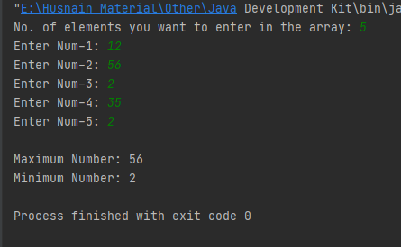

### Hand in

Hand in the source code from this lab at the appropriate location on the LMS system.

### To Receive Credit

1. Comment your program heavily. Intelligent comments and a clean, readable formatting of your code account for 20% of your grade.
2. The lab time is not intended as free time for working on other assignments.